

Hummingbird – Rhino-Grasshopper

User Guide

Mario Guttman

Revised 2019-04-29

Based on Rhino 6 and Revit Version 2020

I. Overview 2

II. Example Project 4

III. Grasshopper Component Reference 8

IV. Installation 28

The *Hummingbird* solution includes a set of components for Rhino-Grasshopper and an add-in for Revit called *ModelBuilder*.

This document describes the Rhino-Grasshopper components. A separate document *Hummingbird - Revit Addin.pdf* describes the Revit add-in. This document includes more detail about the .CSV file with is used to transfer output between the Rhino-Grasshopper and Revit environments.

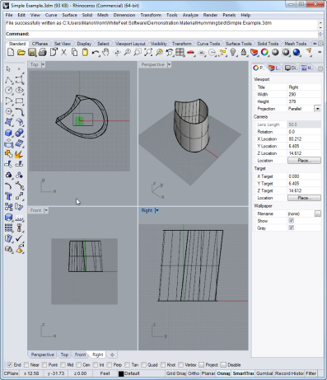 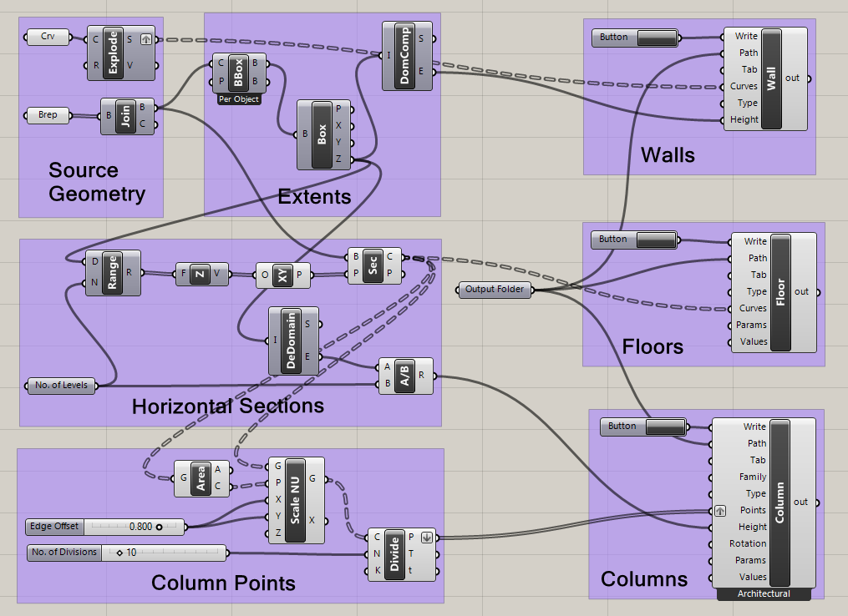 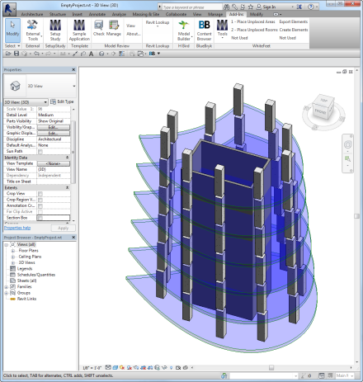

Using Rhino Geometry to Create Native Revit Objects

# Overview

Hummingbird is used to create native Revit objects based on data that is generated from Rhino-Grasshopper. The Grasshopper components write to a .CSV text file that can be read by the Revit add-in Model Builder, which builds the Revit objects. The text file can be viewed in a Hummingbird CSV-Viewer (or Excel) for study and editing data if necessary, however this is not normally required.

The Rhino-Grasshopper components also include an Input tool, which can be used to read CSV data that has been created in Revit or another source. This data is used to create Rhino geometry or data input to other Grasshopper components.

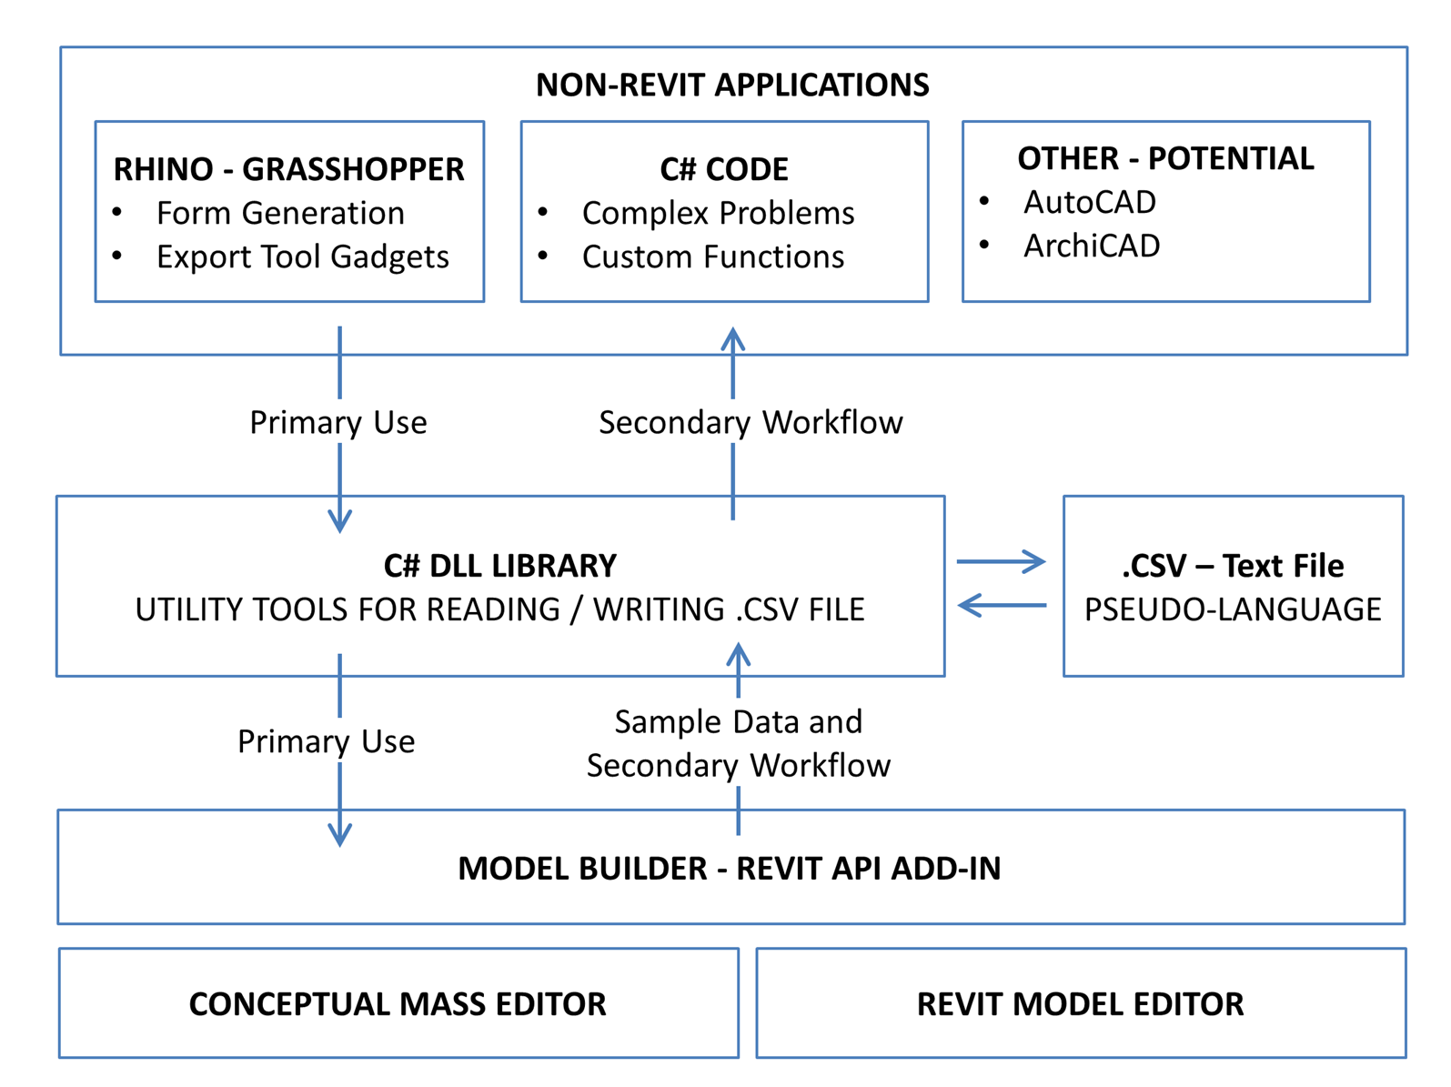

Diagram of the Workflow and Data Model

With Rhino 5 the Grasshopper add-in must be installed. See this site for more information on how to get it: <http://www.grasshopper3d.com/> . With Rhino 6 this is included automatically.

The Hummingbird installation adds the components to the *Extra* tab in Grasshopper.

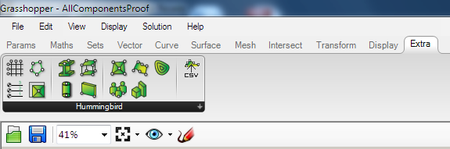

The Hummingbird Components are installed to the Extra Tab in Grasshopper

The Revit ModelBuilder add-in is installed to the *Add-Ins* tab in Revit.

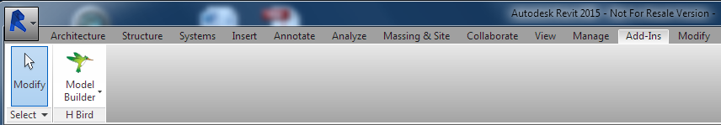

The ModelBuilder is installed to the Add-Ins Tab in Revit

# Example Project

Project is named “Simple Example.3dm” and “Simple Example.gh”.

## Geometry in Rhino

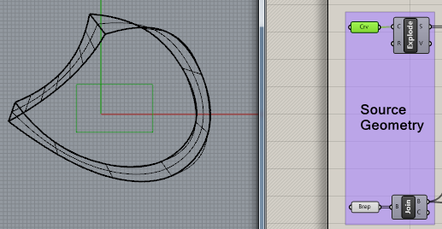 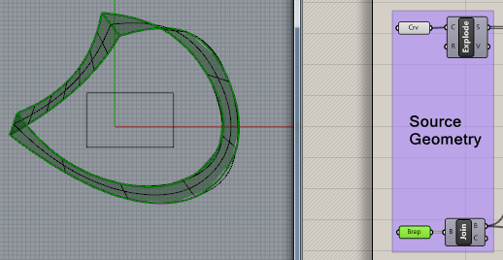

A simple rectangle and lofted surface in Rhino.

## Processing in Grasshopper



### Rectangle for Walls

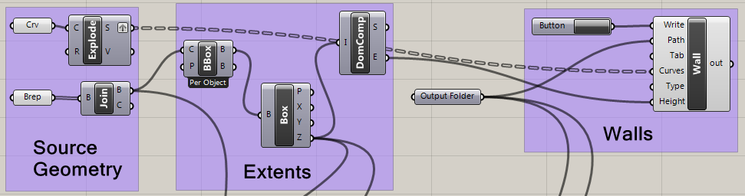

The rectangle is a *Closed Polyline Curve* in Rhino. The Explode component in Grasshopper extracts the four component lines:

The lofted surface is in two parts, which are joined by the *Join* component in Grasshopper. This geometry is used by all three output types. In the Walls case a *Bounding Box* component is used to determine their extents, which are used to set the wall height.

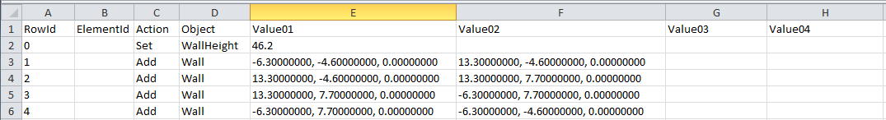

### Horizontal Sections for Floors

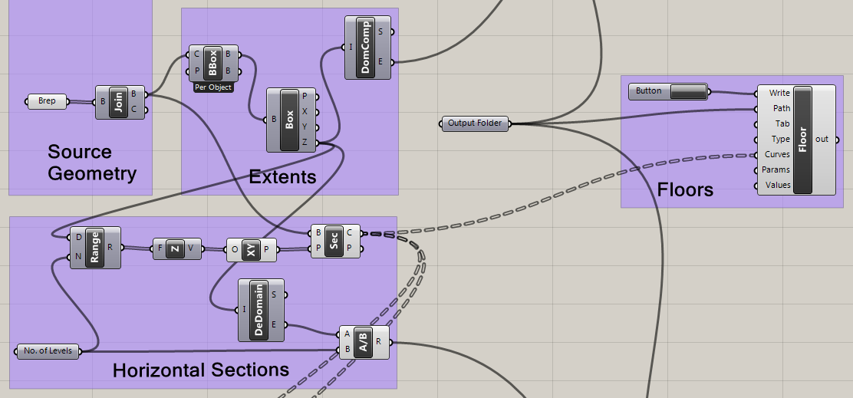

A *Section* component is used to slice the form, providing the curves for the Floors component.

Note that the number of sections is based on a range that uses the same bounding box created for the wall heights.

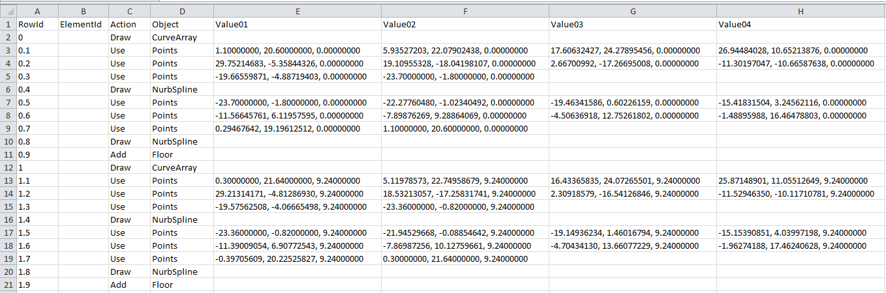

### Horizontal Sections for Column Points

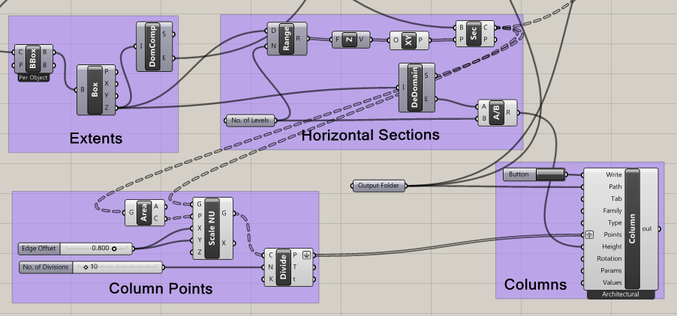

The horizontal sections are also used to generate points for the bottom and top points of the columns.

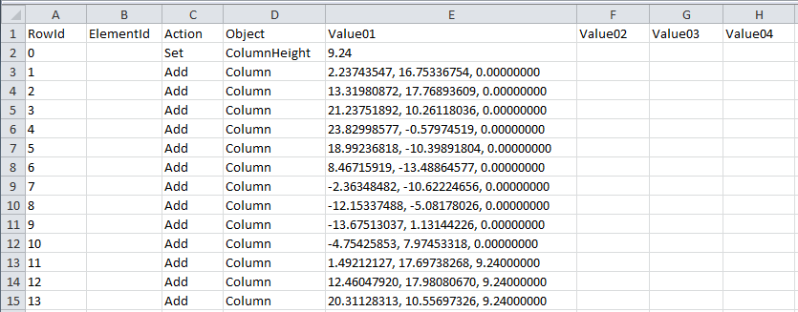

## Objects in Revit

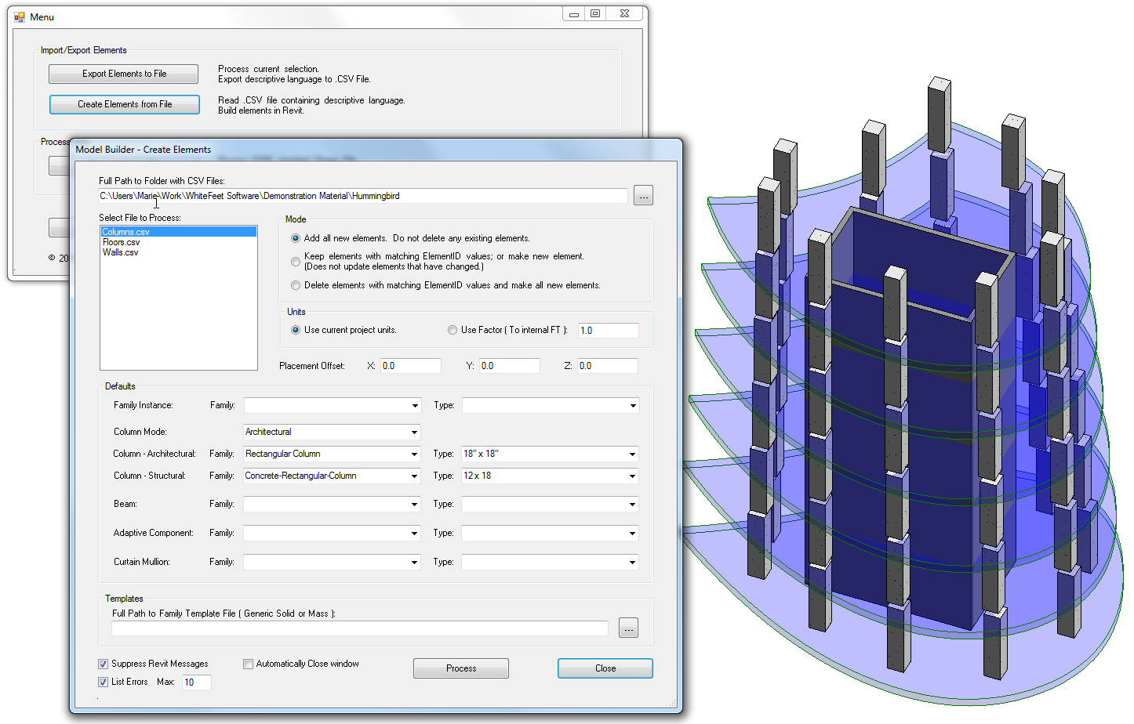

# Grasshopper Component Reference

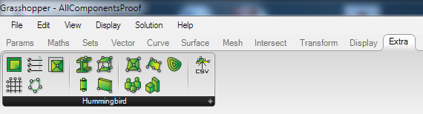

The Hummingbird Components are installed to the Extra Tab in Grasshopper

The Revit Creation components are used to create a .CSV file. The Input component is used to create Rhino geometry from a .CSV file. They all have the same three connectors at the top:

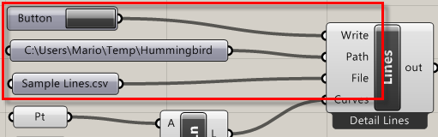

* **Write**: A binary input that is typically connected to a Toggle or a Button. When true is causes the file to be written.
* **Path**: The full path to an existing folder where the files will be written/read.
* **File**: (Optional) the name of the .CSV file to be created/read. If omitted the name of the component will be used.

Existing .CSV files with the same name are overwritten without any warning.

Many components include inputs for **Parameter Name** and **Parameter Value**.

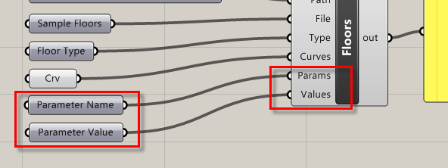

These are always optional. If provided, the names should be a list of existing parameter names that will be set for each instance created. The values should be a tree of values to use with the parameters. The dimensions of the tree should correspond to the number of parameters and the number of instances to be created.

## Basic Revit Elements



**Filled Regions:**

Filled regions are useful as a way of representing a bounded area in Revit. They can include holes and islands in the holes.

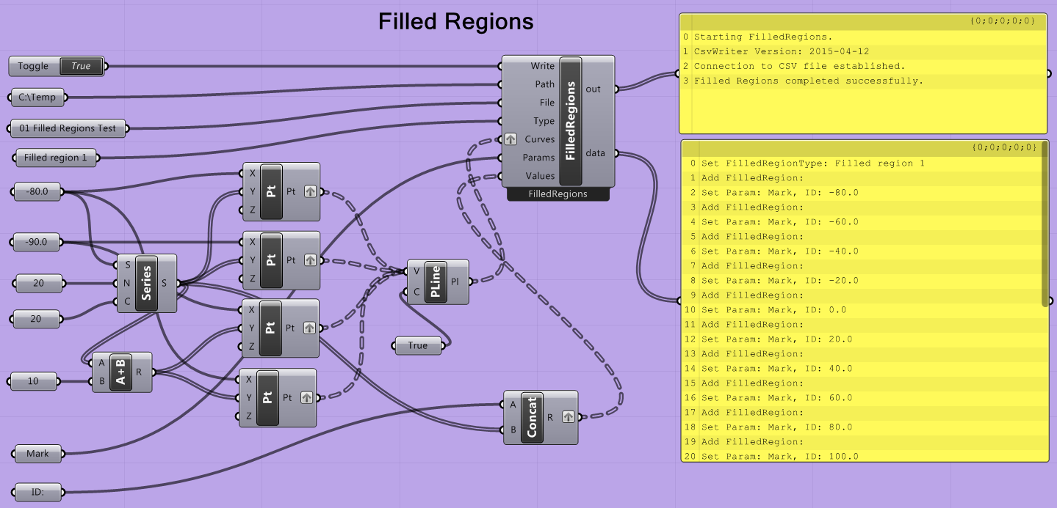

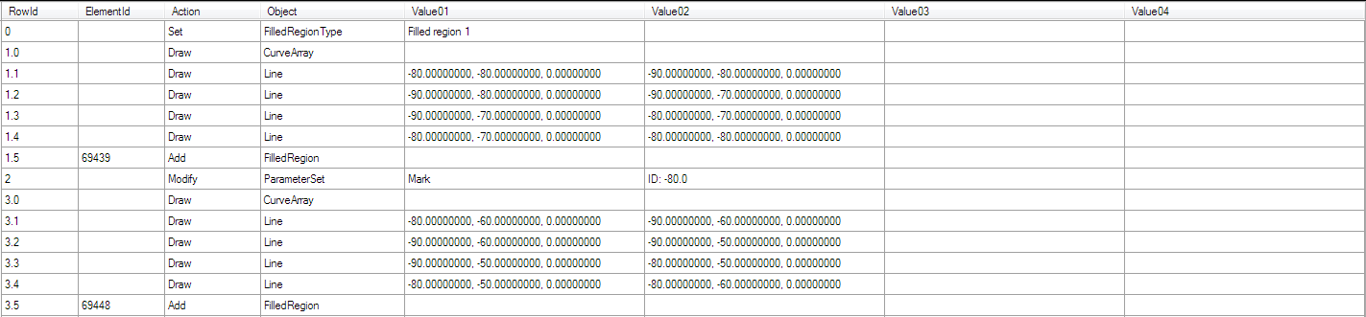

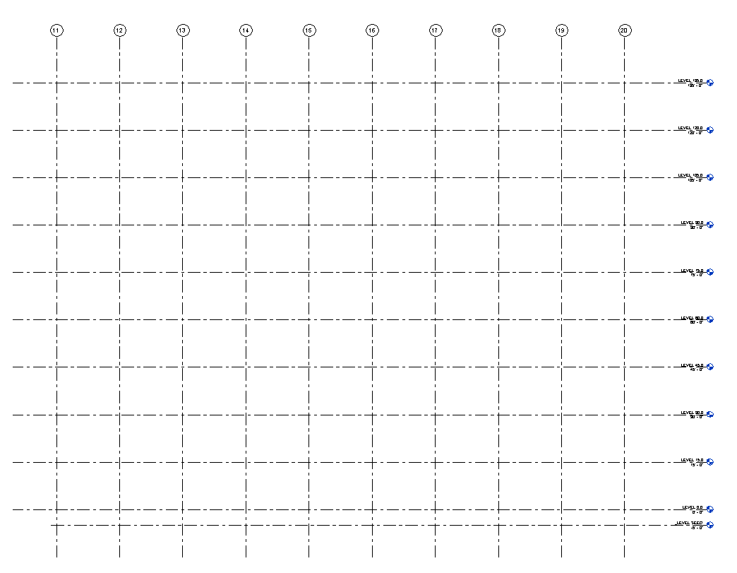

**Grids:**

Native Revit Grids and Levels are built from Rhino data, seen in an elevation view in Revit.

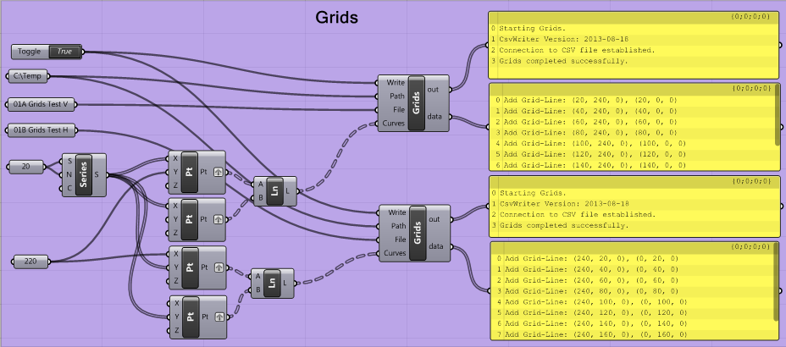

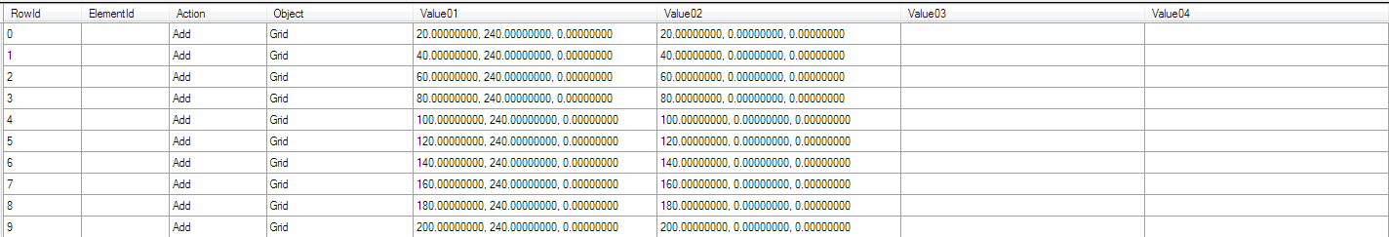



**Levels:**

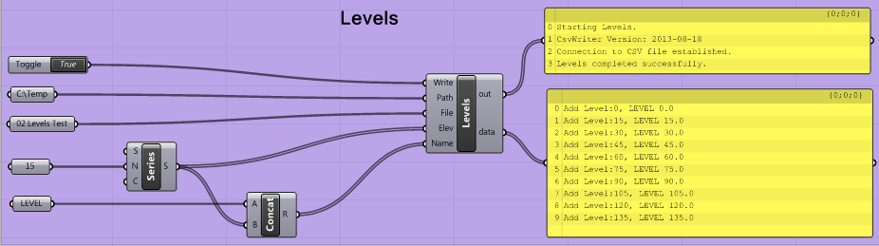

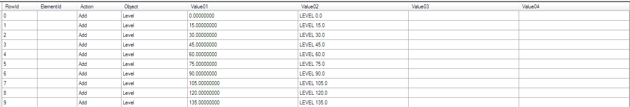

Columns, beams, floors, walls, room separation lines, rooms, and family insertions over a topography surface, all created in Revit from Rhino geometry.

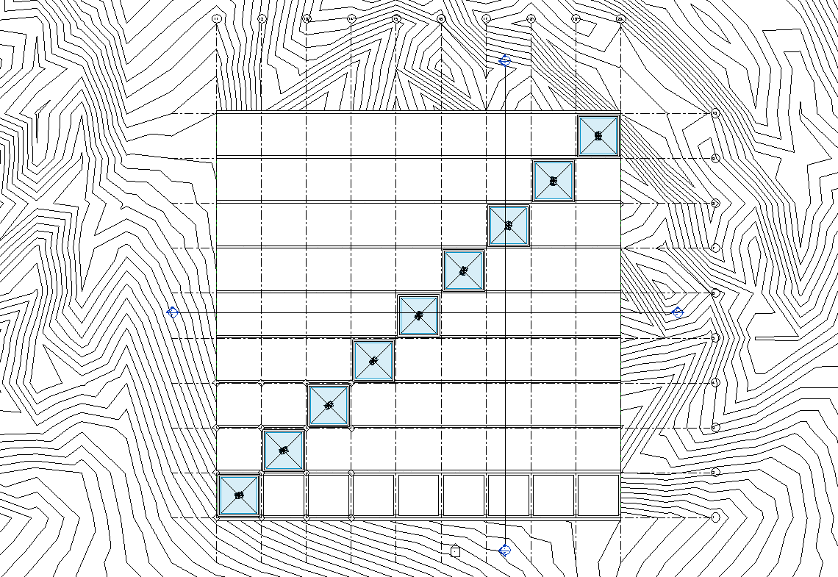



**Lines:**

The **Lines** component processes Rhino curves into lines in Revit.

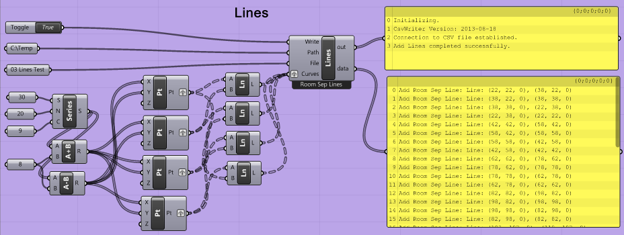

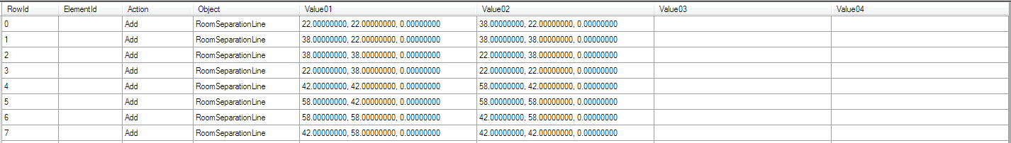

The Curves connection accepts a list of Rhino curves.

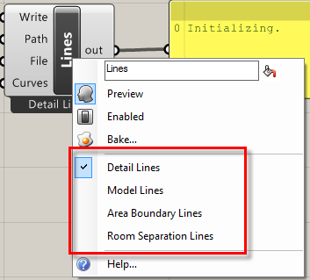The component can create four different kinds of Revit lines: **Detail Lines**, **Model Lines**, **Area Boundary Lines**, and **Room Separation Lines**. By right-clicking on the component the output can be switched between these.



**Rooms and Areas:**

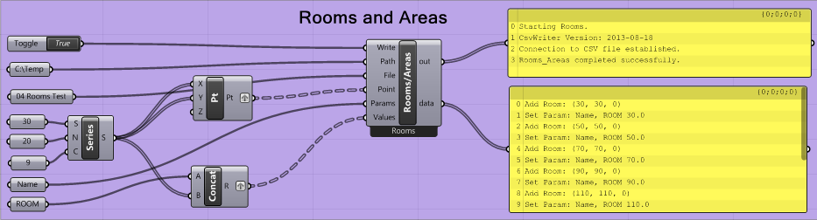

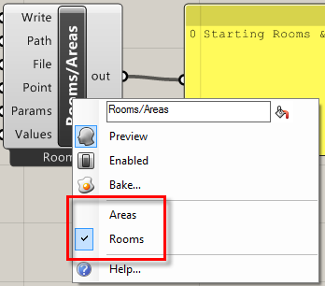 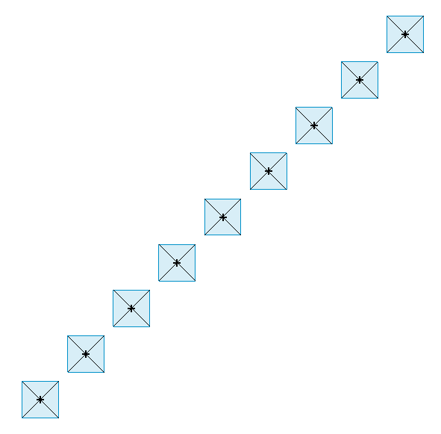

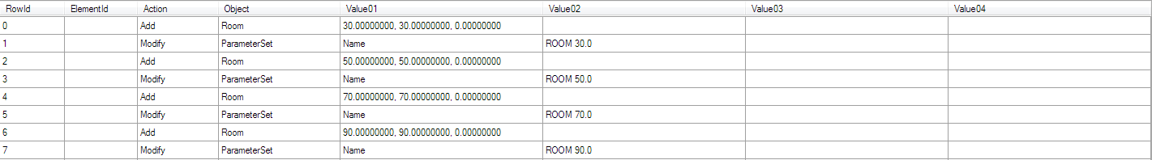

## Simple Revit Forms



**Beams:**

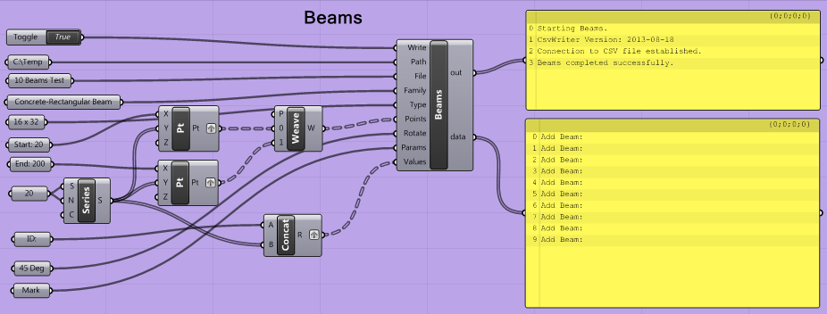

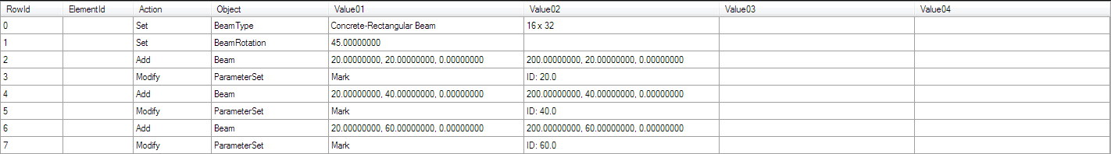

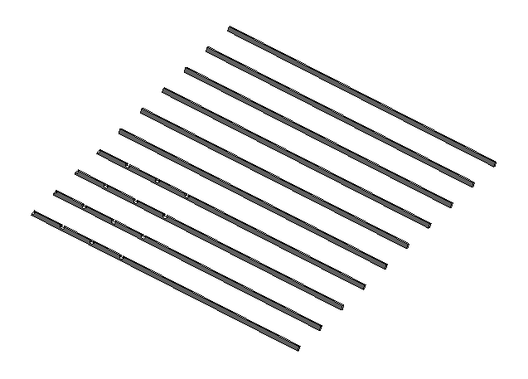



**Columns:**

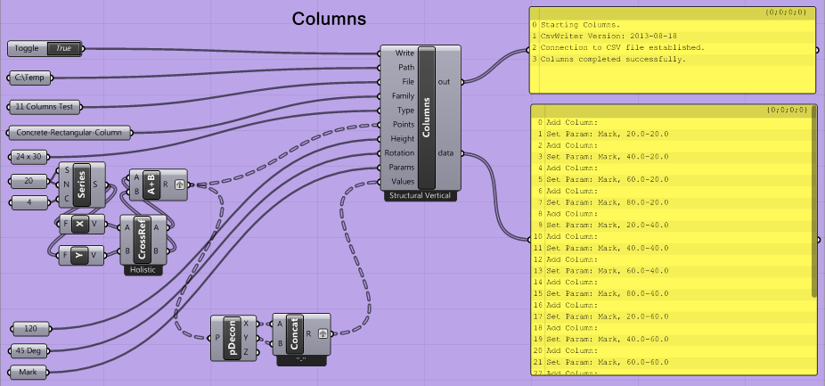

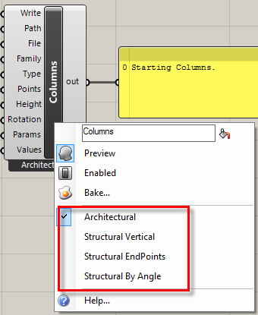 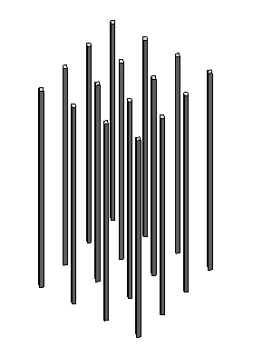

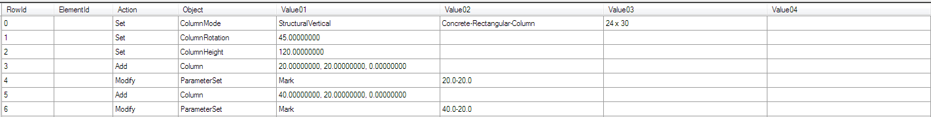



**Floors:**

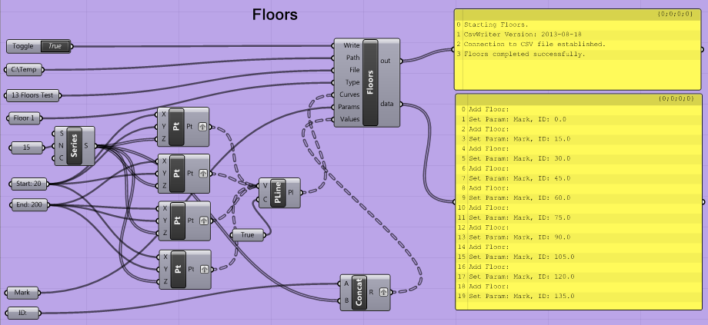

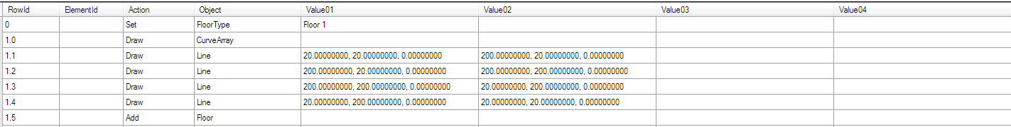

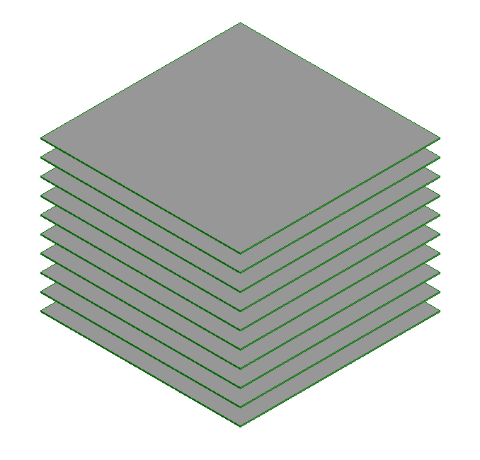



**Walls:**

The **Heights** value may be a single value or a list of varying wall heights.

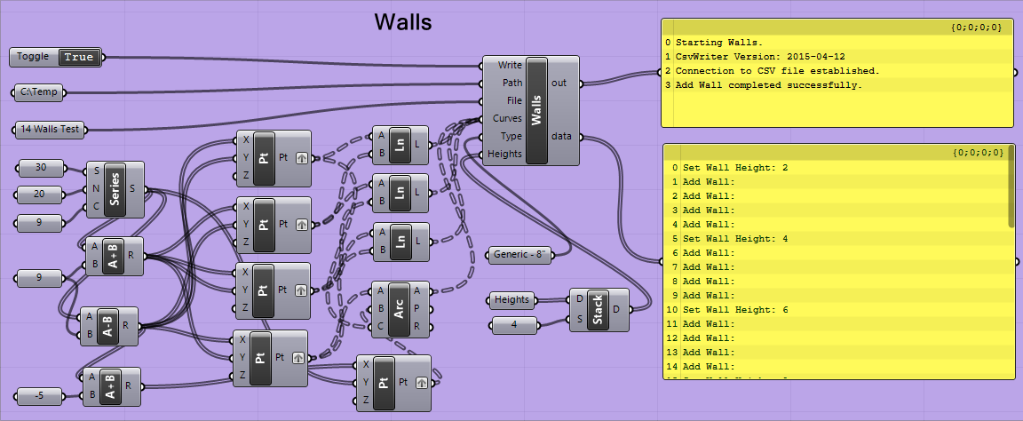

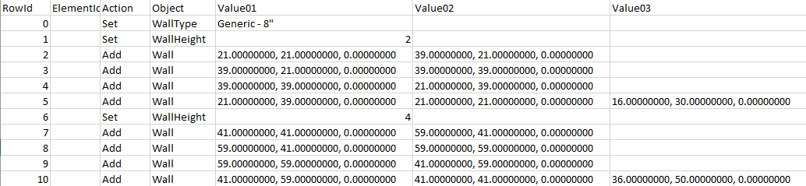

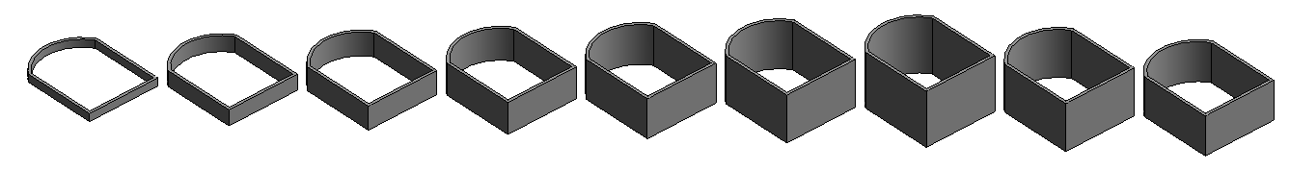



**Curtain Walls:**

The mullions are optional. Grids without a mullion may also be used. It is not possible to add a mullion to the perimeter.

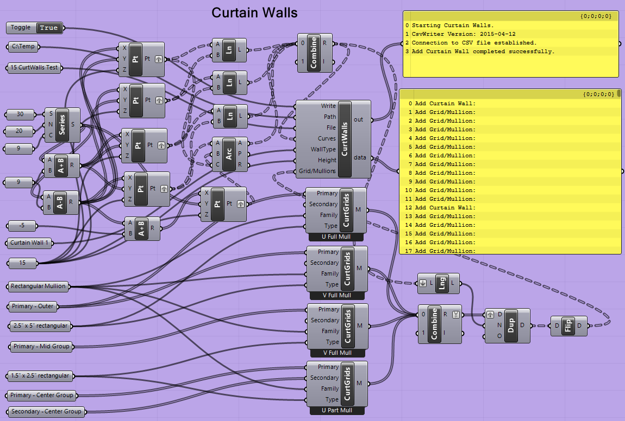

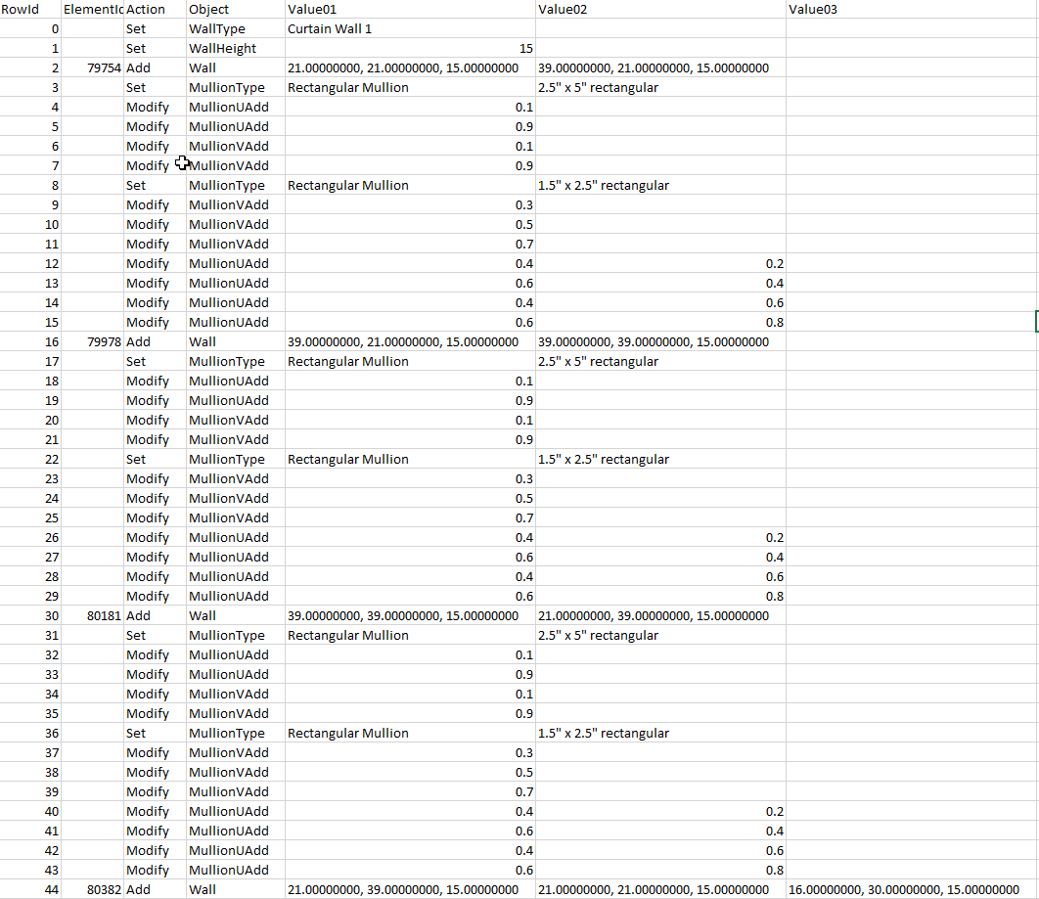

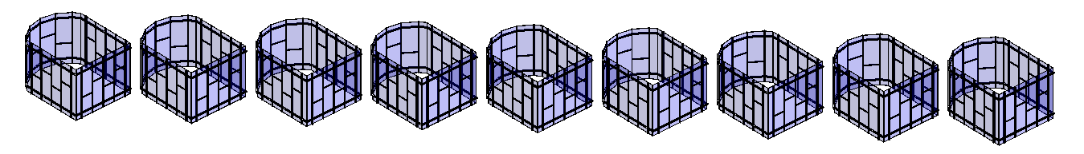

## Complex Revit Forms



**Adaptive Components:**

The **AdapComps** component is used to place an existing adaptive component in Revit and adjust its control points. The correct number of control points must match between the Grasshopper output and the Revit family, and the points must be in the correct order.

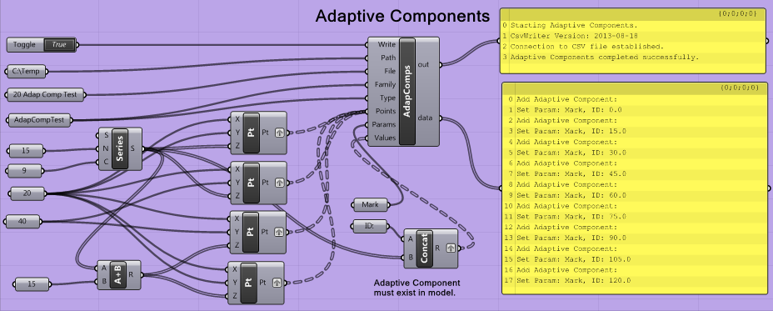

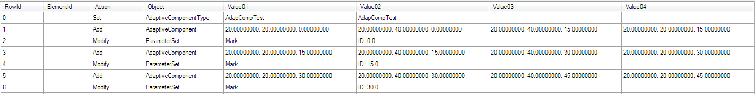

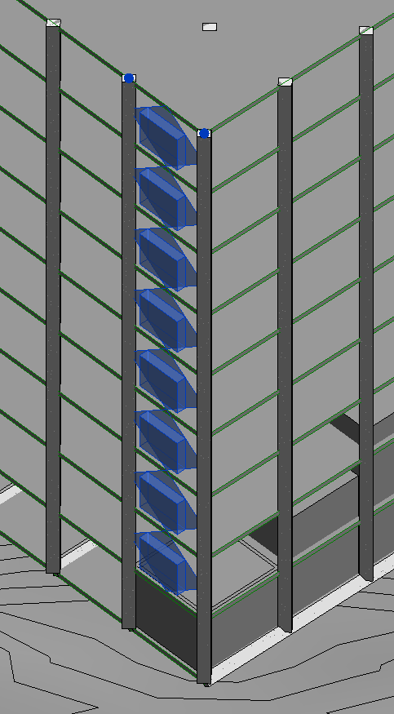

The **Family** and **Type** values are optional. If they are provided, they will be specified in the .CSV file. If not, they will be inferred from the default setting in the ModelBuilder addin in Revit. In either case, the family and type must already exist.



**Families:**

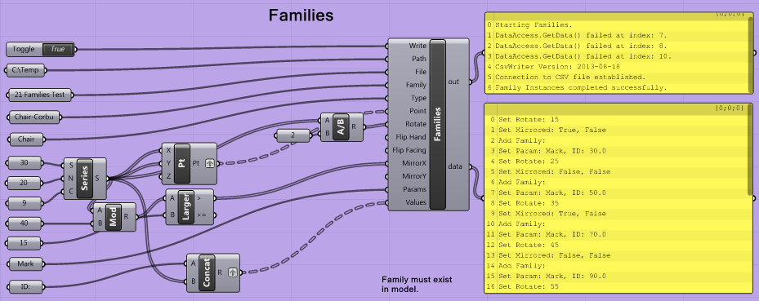

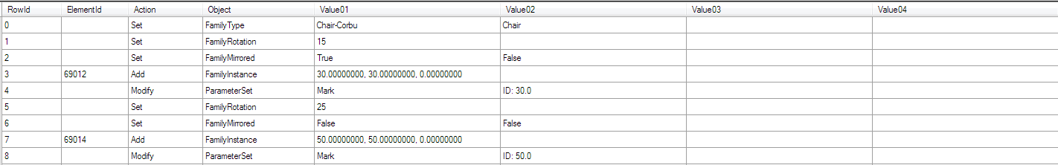

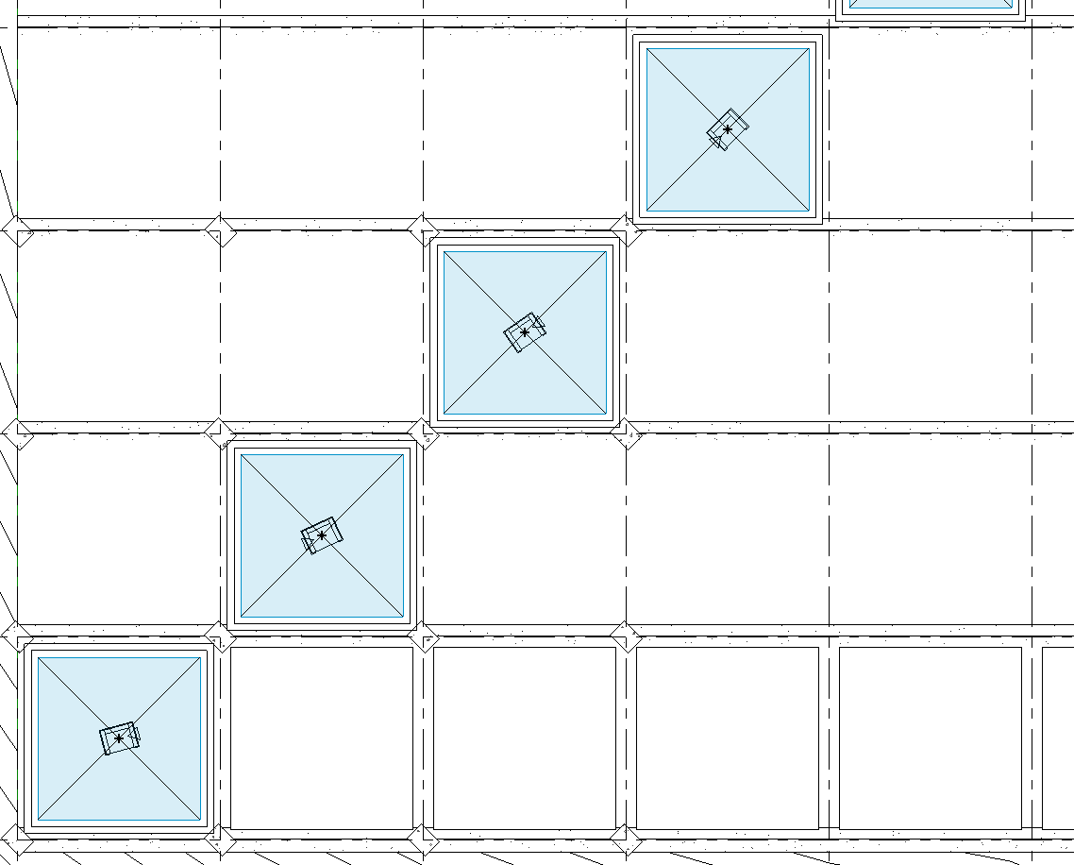



**Loft Forms:**

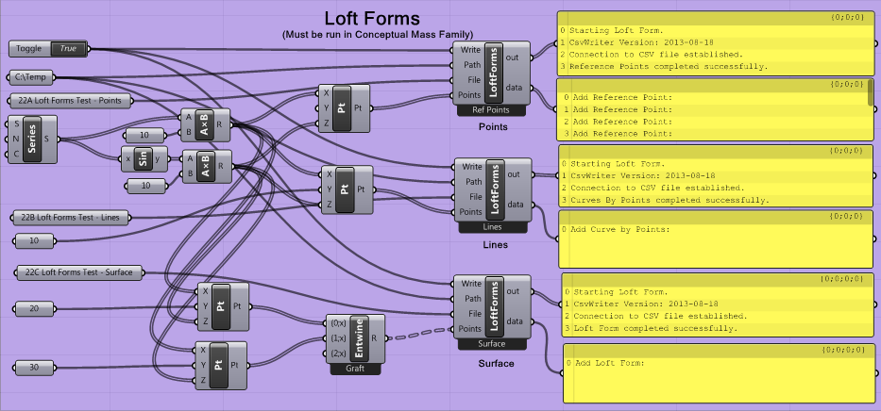

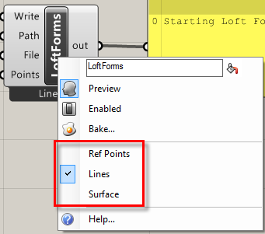

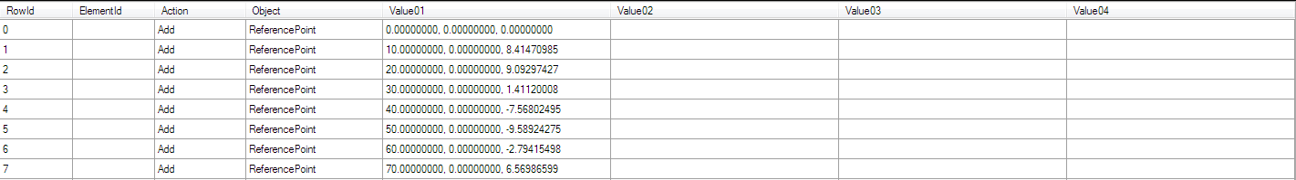



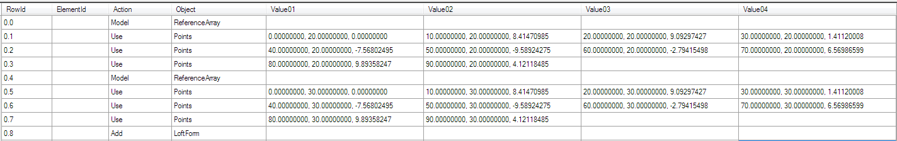

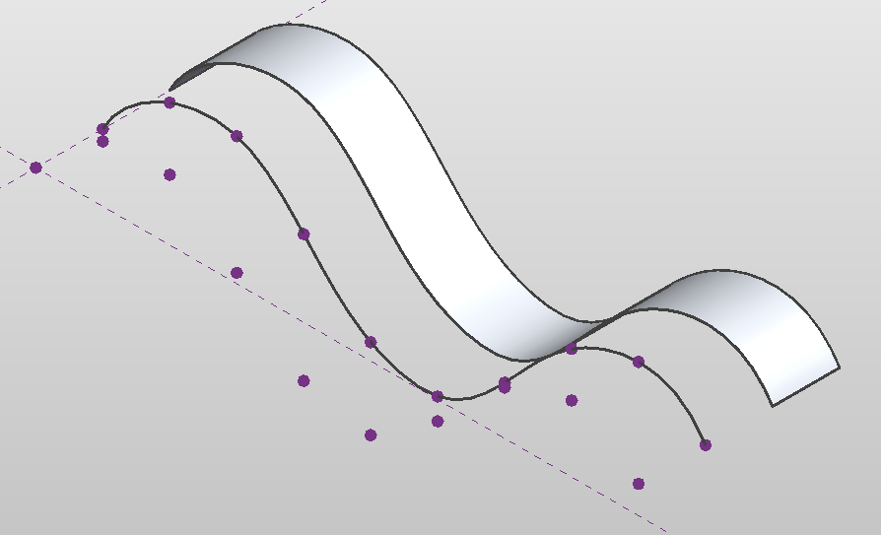



**Mass Families:**

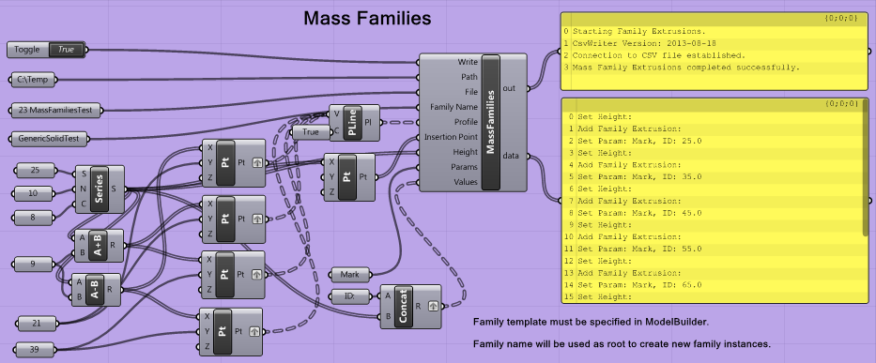

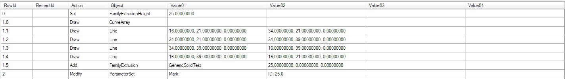

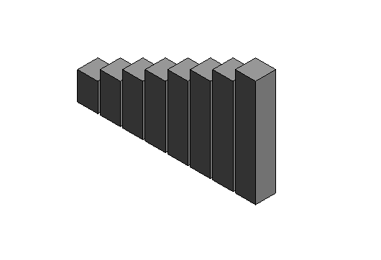



**Topographic Surfaces:**

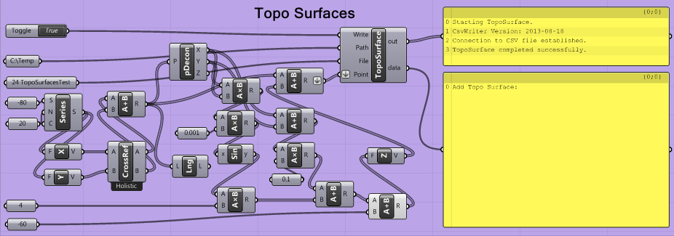





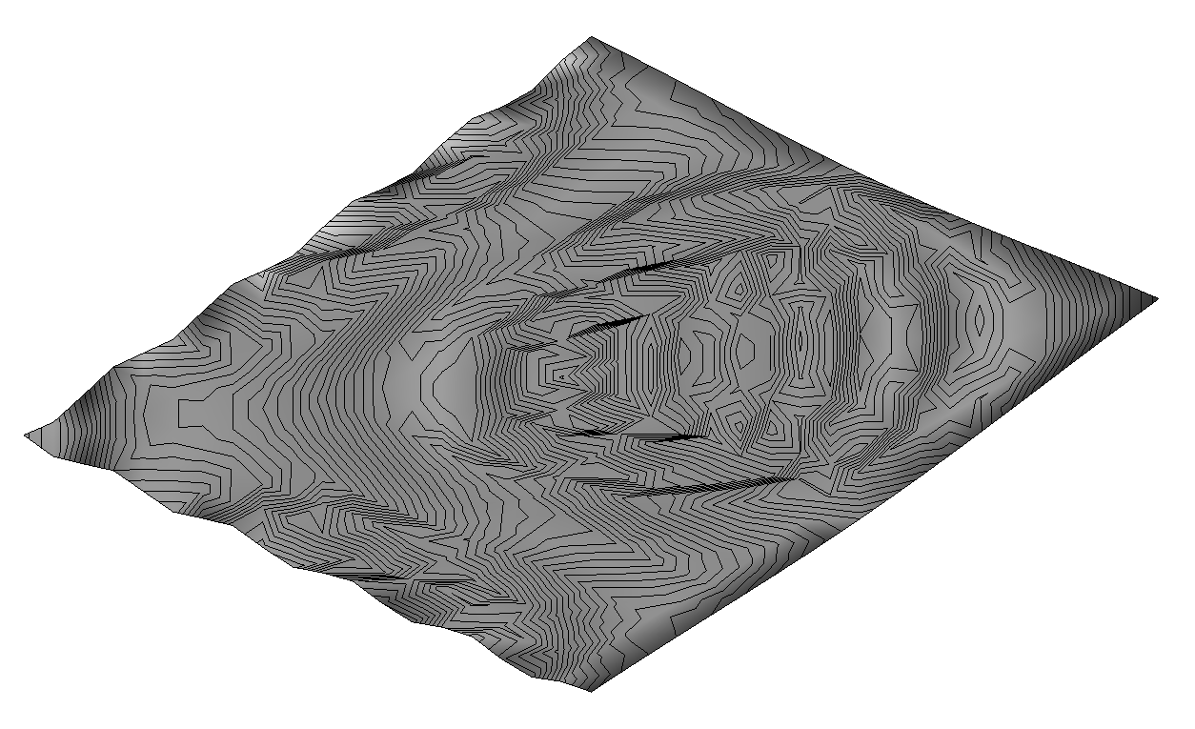

## Rhino Geometry

There is one component that is fundamentally different from the others; instead of using Rhino geometry to write to a .CSV file, it uses a .CSV file to create Rhino data and geometry.

C:\DataWork\Work\WhiteFeet Software\Code - Hummingbird V2\HummingbirdGrasshopper\Hummingbird\Resources\Input.png

**Input:**

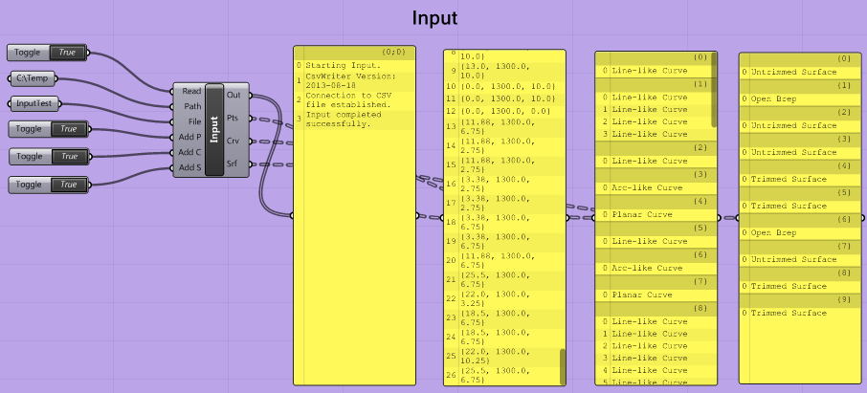

There are two kinds of output:

* The “Add P” (points), “Add C” (curves), and “Add S” (surfaces) toggles control which, if any, geometry to create directly in Rhino.
* The outputs “Pts” (points), “Crv” (curves), and “”Srf” (surfaces) output data in tree structures for use with other Grasshopper componetns.

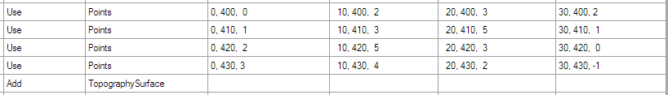

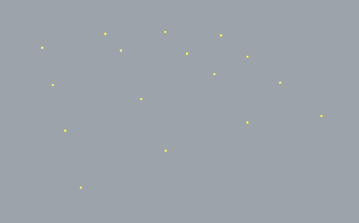 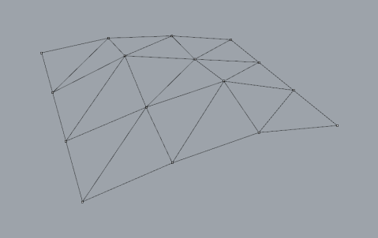 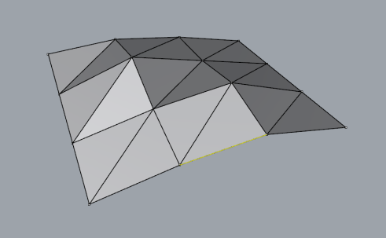

A single .CSV file, in this example a Topography Surface, creates points, lines, and surfaces.

# Installation

All of the Rhino-Grasshopper elements and the Revit add-in are installed automatically by the GrasshopperSetup.msi file. Double-click this file to run it. The file can also be used to repair or uninstall Hummingbird. It can also be uninstalled from the Windows Control Panel.

If a manual setup is required for some reason the following elements are necessary:

## Rhino – Grasshopper Setup

The files are installed under the folder: (Note: the same folder is used for Rhino 5 and 6.)

C:\Users\<UserName>\AppData\Roaming\Grasshopper\Libraries\Hummingbird

The folder contains:

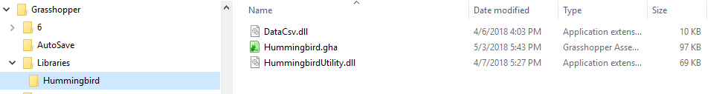

## Revit Setup

The files are installed under the folders:

C:\Users\<UserName>\AppData\Roaming\Autodesk\Revit\Addins\2018\Hummingbird\

C:\Users\<UserName>\AppData\Roaming\Autodesk\Revit\Addins\2019\Hummingbird\

There are two subfolders:

* **Program** (2019 version shown) contains the files:

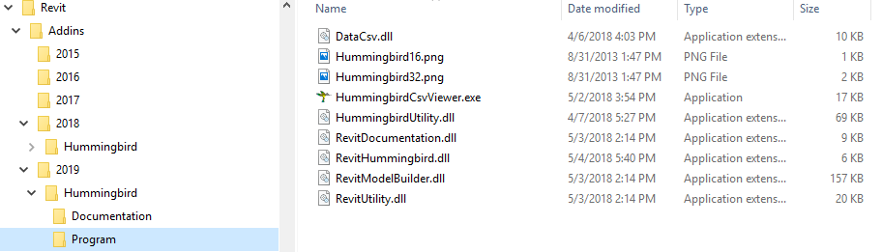

* **Documentation** contains:

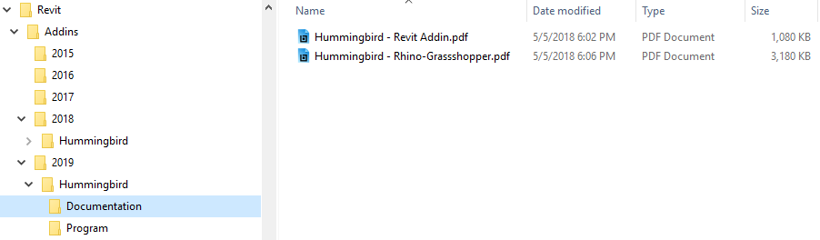

Other files may be placed here and will display when the Documentation command is run from Revit.

An Addin file named “WhiteFeet.Hummingbird.addin” is placed in the folder(s):

**C:\Users\<UserName>\AppData\Roaming\Autodesk\Revit\Addins\2014  
C:\Users\<UserName>\AppData\Roaming\Autodesk\Revit\Addins\2015**

The file consists of:

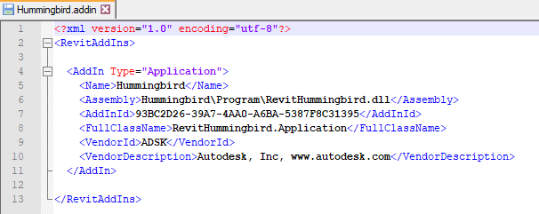

The program also creates a set of folders under:

C:\Users\<UserName>\AppData\Roaming\Hummingbird



These are used to store settings from the Revit addin and the CSV file viewer as a convenience so that the menus restore to their last configuration when they are re-opened. These files may be deleted without harm.